***WordPress on Windows***

**What is WordPress?**

* WordPress is open source software we can use to create a beautiful website, blog, or app.
* It has Beautiful designs, powerful features, and the freedom to build anything you want. WordPress is both free and priceless at the same time.
* WordPress is well-architectured personal publishing system built on [PHP](http://php.net/) and [MySQL](http://mysql.com/).

## Powerful Features

* Customizable Designs
* SEO Friendly
* Responsive Mobile Sites
* High Performance
* High Security
* Powerful Media Management
* Easy and Accessible.

## Software required

* XAMPP- PHP and MYSQL
* Wordpress zip file.

**How to Install WordPress on Windows Computer Using XAMPP?**

Step 1:

Download Wordpress code from <https://wordpress.org/>

Step 2:

Copy the downloaded ZIP file > Paste it to XAMPP htdocs folder > Extract the ZIP File.

Step 3:

Start XAMPP > Apache & Mysql server > Open mysql server on browser > Create one new Database for wordpress (Db name ‘Wordpress’).

Step 4:

Open Extracted wordpress folder > Rename wp-config-sample.php to wp-config.php

Step 5:

Open wp-config.php file > change the following content based on our Database [credentials](https://www.google.co.in/search?q=database+credentials&spell=1&sa=X&ved=0ahUKEwjWgKz4p__ZAhVLQ48KHffdAHcQkeECCCMoAA).

/** MySQL database name */

define('DB_NAME', 'wordpress');

/** MySQL database username */

define('DB_USER', 'root');

/** MySQL database password */

define('DB_PASSWORD', '');

/** MySQL hostname */

define('DB_HOST', 'localhost');

Step 6: - For proxy system

At the end of wp-config.php file, have to add following lines

define('WP_PROXY_HOST','YOUR PROXY HOST');

define('WP_PROXY_POST',YOUR PROXY PORT);

define('WP_PROXY_USERNAME', '');

define('WP_PROXY_PASSWORD', '');

define('WP_PROXY_BYPASS_HOSTS', localhost');

Step 7:

Now open your web browser and go to <http://localhost/wordpress/>

The WordPress database setup will start automatically. First it will ask to select your language. After that it will show you some information about setting up our database.

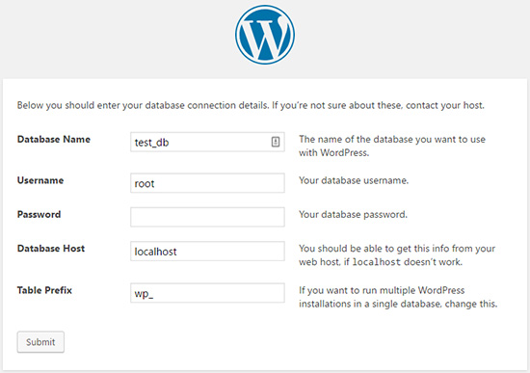

Step 8:

After this we will see a screen informing you that WordPress has successfully connected to your database, and we can proceed with the installation.

Go ahead and click the **Run the install** button.

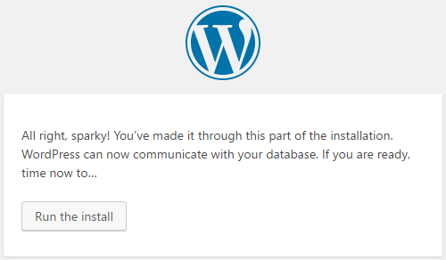

Step 9:

On the next screen, we will fill out the installation form. Need to provide a title for our website, choose an admin username / password, and provide admin email address.

Once you’re ready, press the **Install WordPress** button.

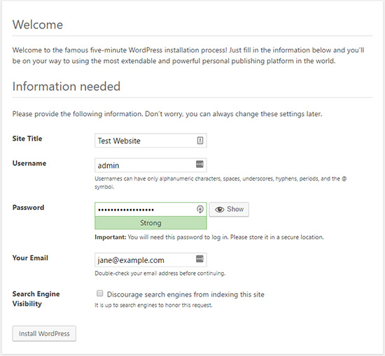

WordPress will quickly run the installation and create database tables. Once done, we will see a success message after the installation is complete.

we can then proceed to our WordPress dashboard by clicking on the **Log in** button.

Now, Successfully installed WordPress on a windows computer using XAMPP.

Step 10:

Now we can see wordpress dashboard, now we can start customization on our website.

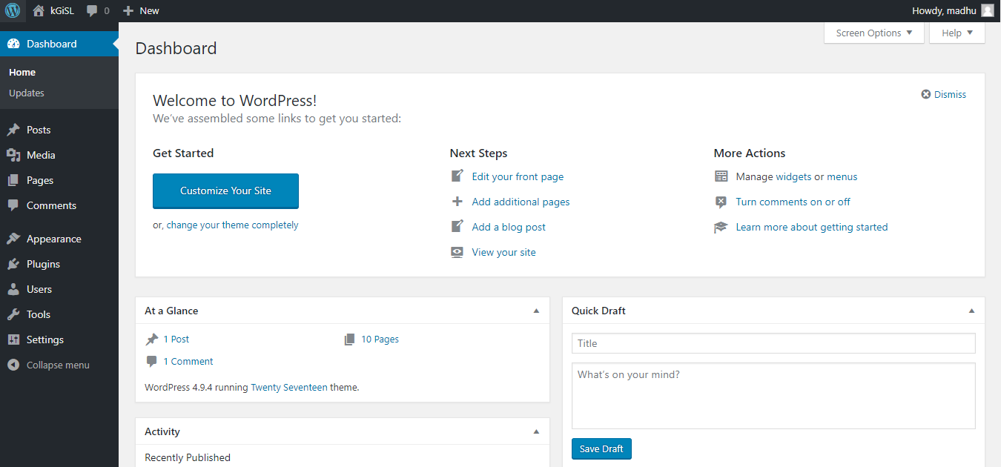

Step 11:

Add chat window

* Open Wordpress website using <https://wordpress.org/>
* Click plugins
* Search ‘livechat’ on search box
* Download plugin as your wish > We can get ZIP file.
* Go to our local wordpress webpage > Click plugin option from side menus.

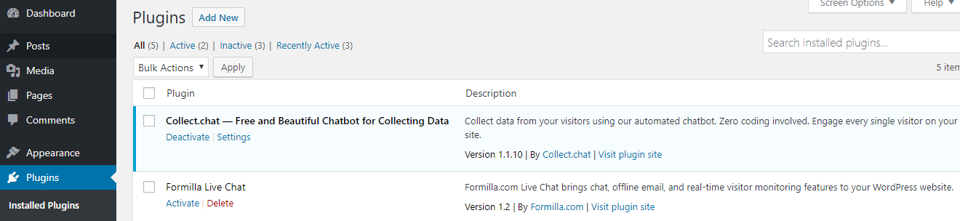

* Click add new button > Click Upload plugin button > Click upload button > Upload our ZIP file > Click install Now > Install it.
* Now we can see the plugin in Installed plugins page
* Click Activate Now and If any setting is required set it. – Get requires guidance and with installation option from Plugin downloaded page.
* Now we can see chat window on our webpage.